National Endoscopy Database (NED)
Business Message Specification
GetBatchStatusMessage

Version: 1.16
Date: 06/11/2013

Contents

1 Contents 2
2 Introduction 3
2.1 Background 3
2.2 Purpose of this document 3
2.3 Scope 4
2.4 Assumptions 5
2.5 References 5
2.6 Abbreviations & Terminology 6
3 Message Content 7
4 Business Message Format 8
4.1 Description 8
4.2 Top Level 8
4.3 batchResultType 9
4.4 errorType 10
4.5 Other Types 11
5 Additional Business Validation (ABV) 11
6 Appendix A – Visualizing the Schema file 12
7 Appendix B – Schema file 13

Introduction
This document provides information concerning the National Endoscopy Database (NED) interface and describes the scope, purpose and overview of the NED project.

Background
The JAG is introducing a facility to enable Endoscopy System Suppliers to submit, electronically, procedure information on behalf of endoscopists to a national database, NED.
Endoscopy System Suppliers who wish to use the NED Import service must register with the JAG to do so.
Use of the NED Import service will remove the need for endoscopist to manually key in procedure data thus saving time, improve quality and increase coverage of procedures recorded throughout England.

Purpose of this document
This document defines the detailed format and content for the logical business message which is passed from the update web service to the Endoscopy System Supplier. The purpose is to inform the Endoscopy System Supplier the status of the data they have uploaded to NED.

Scope
This document is one of a number that when taken together describe the NED Import service. The complete documentation set is shown in the following table, with this document highlighted.
Document | Description
Business Message Specification  SendBatchMessage | Defines the content of the business message that will pass from the Local Endoscopy System to NED.
Business Message Specification  GetBatchStatusMessage | Defines the content of the message received by the Local Endoscopy System when querying the status of a procedure batch in NED.
Interface Specification | Defines the operational interface and security requirements for connecting to NED Import service including the transmission of data.
Website specification | Defines how to use the NED website to upload data manually and monitor procedure data being imported.

The focus of this document is the physical message format of the business messages used for the business information exchange between the end points (Local Endoscopy System and NED).

Assumptions
The content of this document is based on the following assumptions.
- The procedure data message will always contain at least one procedure – this implies that the Local Endoscopy System supplier will never send empty batches.

References
The table below lists references to other relevant documentation. References to these documents, within the text of this document, are made using the square-bracket notation shown in the “Ref” column of the table.
Ref | Description
[1] | Interface specification document.
[2] | Website specification document.

Abbreviations & Terminology
This section provides definitions of abbreviations and unusual terminology used in this document.
Abbreviations
Abbreviation | Meaning
ES | Endoscopy System Supplier
NED | National Endoscopy Database
JETS | JAG Endoscopy Training System (www.jets.nhs.uk)
JAG | Joint Advisory Group on GI Endoscopy (www.thejag.nhs.uk)
µg | Microgram (mcg)
Mg | Milligrams
ODS | Organisation Data Service (ODS) codes  For example: RGQ for IPSWICH HOSPITAL NHS TRUST.  A complete listing can be found in the blow  (http://www.connectingforhealth.nhs.uk/systemsandservices/data/ods/datafiles/tr.csv/view)
ERS | Endoscopy Reporting System

Terminology
Term | Meaning
XML Schema | A standard for defining the format of XML documents. The standard provides a means by which tools can know the correct format of a document, enabling them to provide generic operations such as validation

Message Content

This section of the document provides detailed descriptions of the business data content that is contained within each business message that can be communicated over the NED Import service interface.
It defines, at a detailed level, the business data that each message communicates and the technical format for the representation of that business data. It does not contain any information related to the creation of a message or the mechanism of its delivery, nor does it define the format of message wrappers or headers. All these are covered in the Interface Control Document [1].
XML documents provide the ability to organise data contained within them hierarchically. This approach is reflected in the data definitions that follow, both to indicate how the data is organised and to allow lengthy definitions to be provided in a digestible manner. The approach taken is to describe data content at higher levels and, within these, make reference to lower level detail that is subsequently expanded. These lower levels of the data structure are referred to within the text as sub-structures. In XML, these are known as complex types.
The data content is described in tabular format and using diagrams to illustrate the XML structures used. Each data item is described by name and by a more lengthy description. A column indicates whether the data item is mandatory or optional and a further column defines the type or format of the data.
Data items within a lower level sub-structure that is referenced from higher levels may be marked as mandatory even though the entire sub-structure is marked as optional at the higher level. Where this occurs, it indicates that the data item is mandatory within the sub-structure if the sub-structure is included.
The Type/Format column either describes the format of the data for the relevant data item (e.g. YYYY for a 4-digit year) or references a description elsewhere. Where this references a lower-level sub-structure that is defined as part of the definition of that message, the name used to make that reference is shown in italic text and refers to the relevant sub-heading within the document. References are also made to sub-structures that are applicable to more than one message (shared complex types) and to definitions that describe a set of valid values to which the item is constrained or other formatting constraints that are too lengthy to fit neatly in the table. These are defined in separate sub-sections of this section of the document after the individual message definitions.
The tables provided for the message includes an additional column labelled ‘ABV’. This column includes a ‘Y’ (for ‘Yes’) to indicate items that have additional business validation (i.e. over and above XML schema validation) upon receipt of the message from NED. The additional business validation is described in section 5 of this specification.
The XML schemas that specify these message formats at a machine-readable technical level are provided at the end of this document.

Business Message Format

Description
This data definition describes the logical groups for this message. It provides the data for a batch of sessions belonging to a hospital/unit, each batch contains one or more procedures.
Note: The complete expanded visual representation of the XML Schema can be found in Appendix A.

Top Level
The following diagram and table describe the data content of this data definition at the top level, with the sub-sections that follow drilling down into further detail.
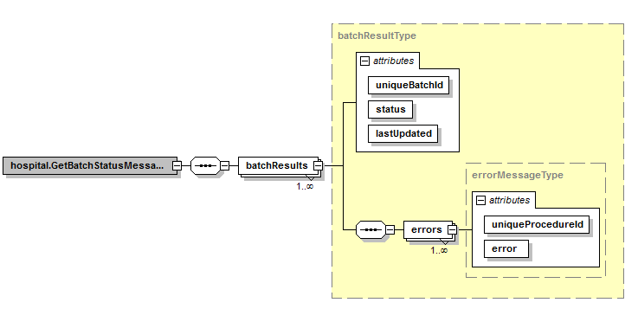

Type | Description
batchResults | Provides result information for each batch that has been updated since the last Polled Date/Time passed to the web service.
errors | Provides a list of errors that have occurred whilst processing a particular batch.

batchResultType
The batch result structure provides various elements of information relating to a given batch.
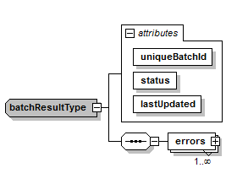

Content | Type | Description | ABV | M/O
uniqueBatchId | string | The local batch identifier defined by the Endoscopy System Supplier. |  | M
Status | statusEnum | The Status of the batch.  See Other Types sub-section. |  | M
lastUpdated | DateTime | The date and time of the update. |  | M
Errors | errorType | If the status of the batch is “Error” then this type will contain the details of each error. |  | M

errorType
The procedure structure provides various elements of information relating to a procedure.

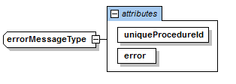

Content | Type | Description | ABV | M/O
localProcedureId | string | The local identifier of the procedure defined by the local Endoscopy System Supplier. |  | M
error | String | The error message relating to this procedure. |  | M

Other Types

StatusEnum
Permitted values for indicating the status of the batch.
Valid Values | Meaning
Queued | The batch of procedures have been queued for import into NED.
Error | An error occurred preventing a successful import.
Imported | The batch of procedures have been successfully imported.

Additional Business Validation (ABV)

There is no additional business validation for this message type.

Document Control

Date | Version | Change
20/01/2014 | 1.01 | Initial version
24/01/2017 | 1.16 | Document version number updated to bring in line versioning with Schema and “Business Message Specification – SendBatchMessage”.  There were no technical changes to this document.

Appendix A – Visualizing the Schema file
The following diagram shows a visual representation of the XML schema in its entirety.
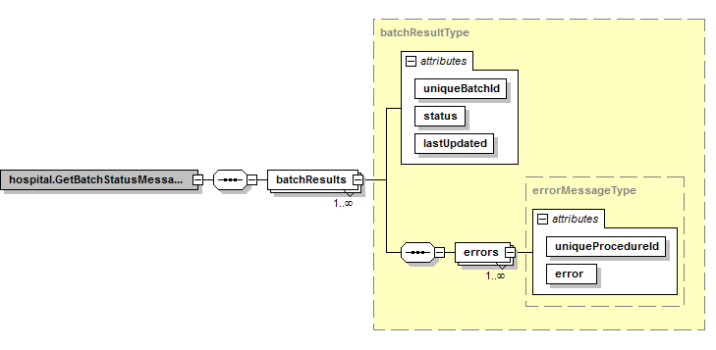

Appendix B – Schema file

<?xml version="1.0" encoding="utf-8"?>
<!-- Version 1.16 -->
<xs:schema
xmlns="http://weblogik.co.uk/jets/Hospital.GetBatchStatusMessage.xsd"
xmlns:mstns="http://weblogik.co.uk/jets/Hospital.GetBatchStatusMessage.xsd"
xmlns:xs="http://www.w3.org/2001/XMLSchema"
targetNamespace="http://weblogik.co.uk/jets/Hospital.GetBatchStatusMessage.xsd"
elementFormDefault="qualified" id="GetBatchStatusMessageFile">
<!-- Root Element -->
<xs:element name="hospital.GetBatchStatusMessage">
<xs:complexType>
<xs:sequence>
<xs:element name="batchResults" type="batchResultType" minOccurs="1" maxOccurs="unbounded"/>
</xs:sequence>
</xs:complexType>
</xs:element>
<!-- Batch Element-->
<xs:complexType name="batchResultType">
<xs:sequence>
<xs:element name="errors" type="errorMessageType" minOccurs="1" maxOccurs="unbounded"/>
</xs:sequence>
<xs:attribute name="uniqueBatchId" type="xs:string" use="required"/>
<xs:attribute name="status" type="StatusEnum" use="required"/>
<xs:attribute name="lastUpdated" type="xs:dateTime" use="required"/>
</xs:complexType>
<xs:complexType name="errorMessageType">
<xs:attribute name="uniqueProcedureId" type="xs:string" use="required"/>
<xs:attribute name="error" type="xs:string" use="required"/>
</xs:complexType>
<xs:simpleType name="StatusEnum">
<xs:restriction base="xs:string">
<xs:enumeration value="Queued"/>
<xs:enumeration value="Error"/>
<xs:enumeration value="Imported"/>
</xs:restriction>
</xs:simpleType>
</xs:schema>

